**K8S – Name spaces Issue and resolution**

While discussing name space concept, we could not able to create name spaces via manifest files. Hence, we created ns manually by  ( kubectl create ns dev).I think it did not worked out well. Because, I have kept different versions in labels section of  qa, env ( 2.00)  and uat (3.0.0) as below screen shot. To test, I have applied in all the environments, which shows default version which we have mentioned in deployment.yaml.  
 It is not showing the versions in diff environments.

Steps as below

original deployment file with version 1.0.0

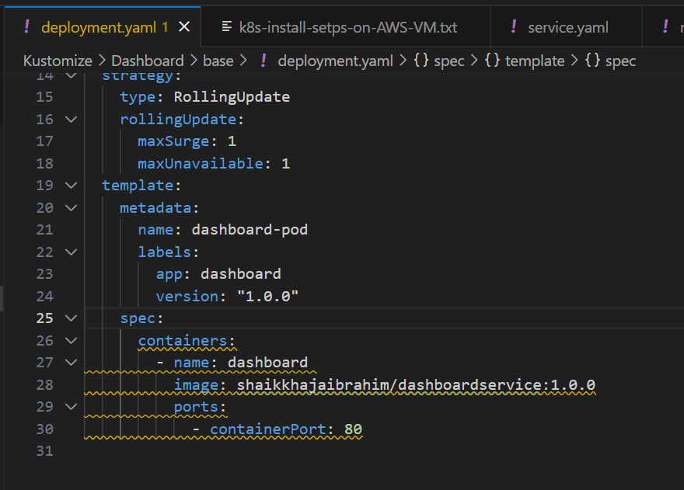

**QA & DEV env labels with version dev= 1.0  & QA = 2.0**

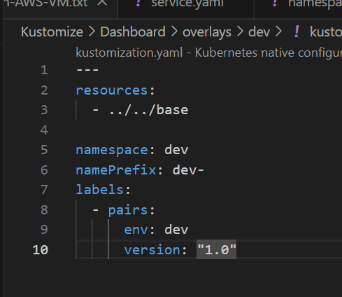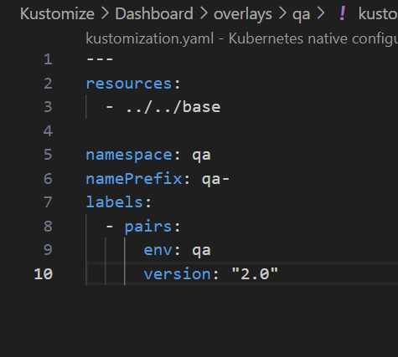

But after applying in respective envs as ( kubectl apply -k . ) it is not taking values from env files. In-fact, I believe it is referring to deployment.yaml version only

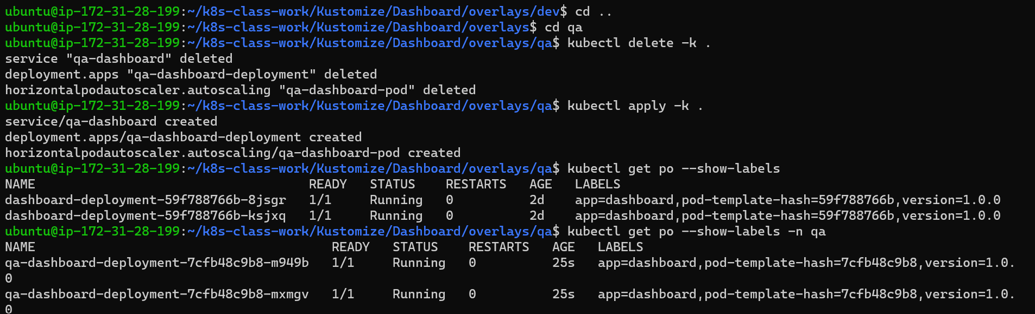

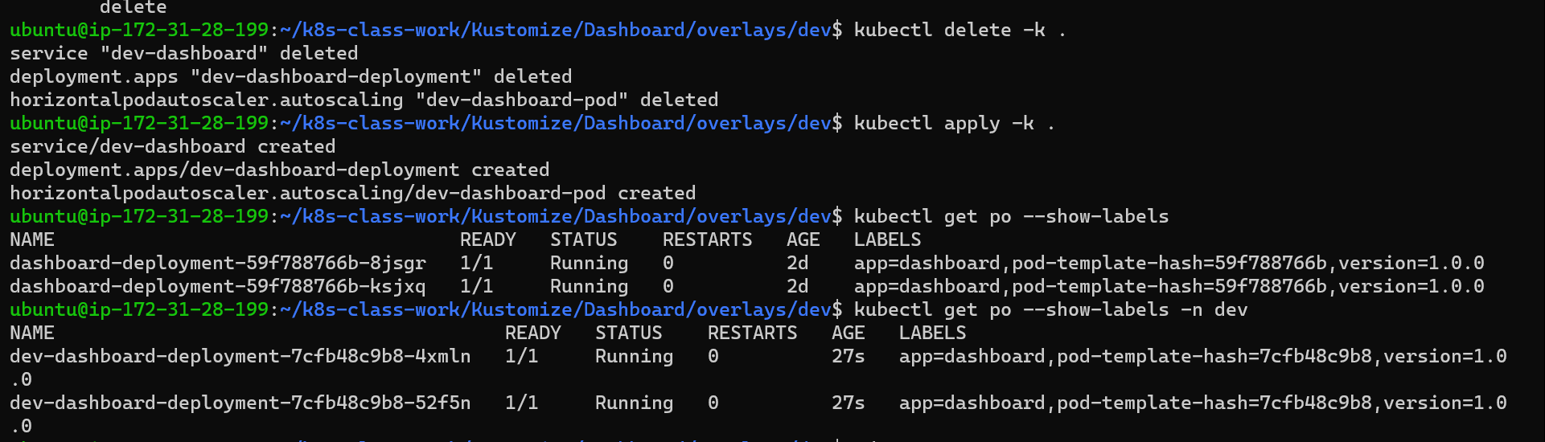

To recheck, I have tried changing the version in deployment .yaml

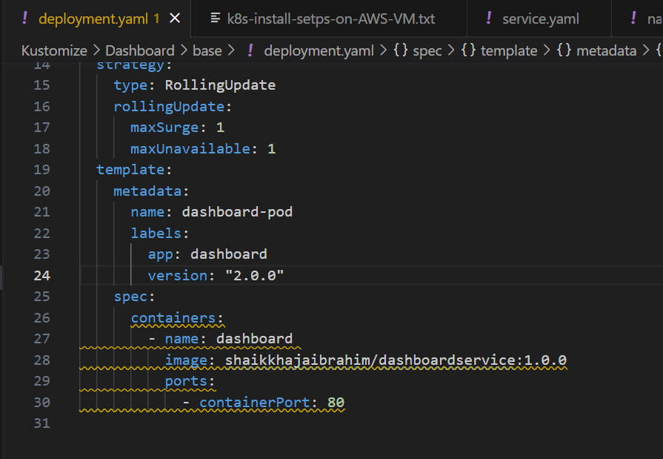

As expected, The changes are not picking from envs. reflecting from version specified in deployment.yaml

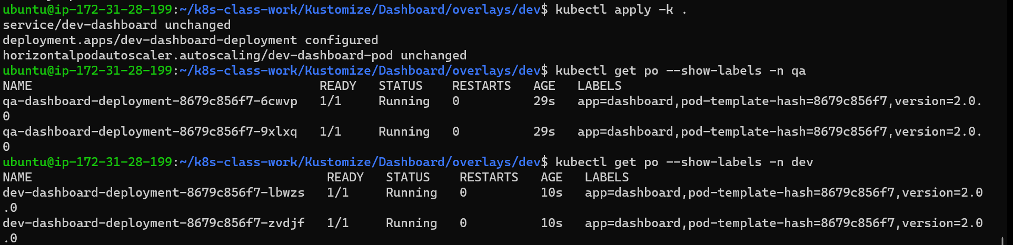

To try again, I have tried deleting the name space which we created manually ( kubectl delete ns dev)  and tried with manifest files. It is not working.



**Solution**

Hope, I have cracked it.

**As a step 1:** first we need to run the namespace.yaml file as ( kubectl create -f namespaces.yaml ) which will create the name spaces.  
namespace/dev created  
namespace/qa created

namespace/uat created.



**Step 2:** Apply all the changes as per the env ( kubectl apply -k ./ )

**Step 3** : We need to look into all the services: as  ( kubectl get all --show-labels -n dev ). Refer below image for changes:

**Note:** I have changed label version as **(1.0.3)** in ../ ../dev/kustomization.yaml, which is reflected as same

